

Learning Packet-
Kentucky Family and School Partnership 101 Training Module

Ky Collaborative for Families and Schools (Ky’s SFEC) is a network of families, educators and community
partners focused on increasing open communication, learning opportunities and shared decision-making
power across the Kentucky Education system. We believe high-quality, equitable and inclusive education
is the shared responsibility of families, schools and communities.

Learning Objectives (3 total training hours)
- Gain a deeper understanding about the importance of family and school partnerships
- Examine core beliefs about family and school partnerships
- Learn and apply concrete strategies for increasing family engagement in your school
- Analyze the findings from your KY Family and School Partnership Self-Assessment
- Learn and apply the 6 Essential Conditions from the Dual-Capacity Building Framework
- Explore family engagement action teams and action plans
- Confirm your next steps for improving family engagement at your school

Recommended reading and credits for many resources in this presentation:
- Beyond the Bake Sale, Henderson, Mapp, Johnson, Davies (2007)
- Powerful Partnerships, Mapp, Carver, Lander (2017)
- “Ky Family and School Partnership Guide”
- www.dualcapacity.org
Tools You Will Receive through Training Module (Full 3 hours):
- Video examples of effective FE
- FE definition and research highlights
- “Dahab’s Story” on Redefining FE
- 5 Roles Families can play
- Where to start ideas
- KY’s 11 Goal Post Strategies
- 5 Objectives for effective family engagement
- Quick School Self Reflection Tool
- 1 action item and 1 new connection (in person/live)
- KY Family and School Partnership Self-Assessment
Beginning of Part 1 of 2
SECTION 1:
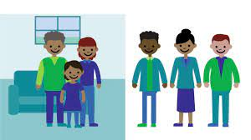
What Could Family Engagement Look Like Video
https://www.youtube.com/watch?v=SgoRN4n0GGs
Ideas and reflections:

What stood out to you in this video? If you were defining family engagement from this video, what key words would come to mind?

SECTION 2:
Kentucky Family Engagement (FE) Definition:
A productive, equitable and inclusive partnership among families, educators and the community to promote children’s learning and development from birth through college and career, and across home, school, and community settings.
Family, school and community partnerships are about building active, reciprocal relationships in which schools, families and community agencies and organizations engage in meaningful and culturally appropriate collaboration to improve student outcomes.

How do you define family engagement?

FE Research:

“Students with involved parents, no matter what their income or background, were more likely to:
• Earn higher grades and test scores and enroll in higher-level programs.
• Be promoted, pass their classes, and earn credits.
• Attend school regularly.
• Have better social skills, show improved behavior, and adapt well to school.
• Graduate and go on to postsecondary education (“A New Wave of Evidence” Henderson and Mapp, 2002)

“According to a national survey of teachers in the US, engaging families is the number one area where teachers feel least well prepared and represents their greatest challenge”(MetLife Survey of the American Teacher, 2005)

Have you experienced this research to be true in your work with families and/or teachers? If yes, what is an example? If not, what are your reflections of these research highlights?

SECTION 3:
Dahab’s Story: “It’s Time to Redefine Family Engagement”

“Our parents were so dedicated to our education that they helped us with our homework every night. They would borrow or buy next-grade-level textbooks for us to study before we started school in the fall. We had to learn to type 70 words per minute before we could go out to play with our friends”
Pull Up full Article here:
https://prichardcommittee.org/wp-content/uploads/2021/06/its-time-to-redefine-family-and-community-engagement.pdf
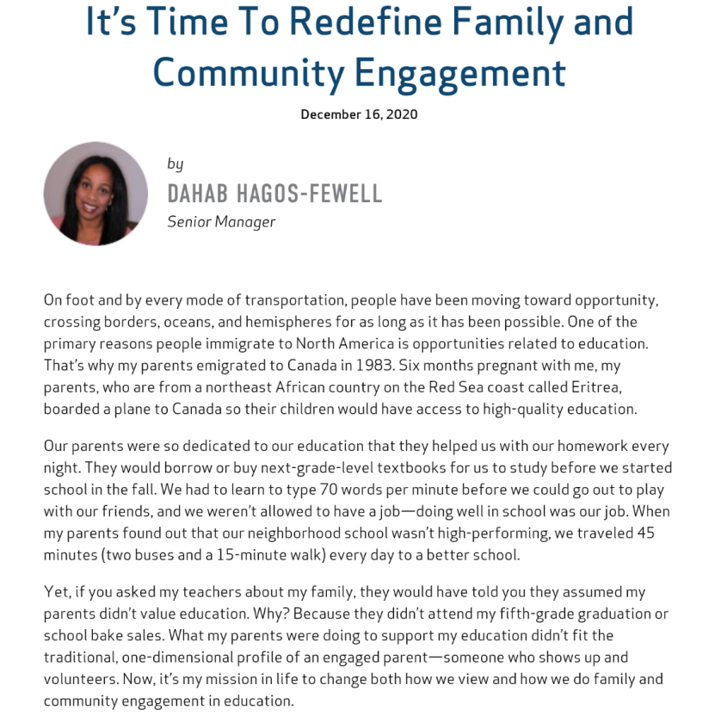
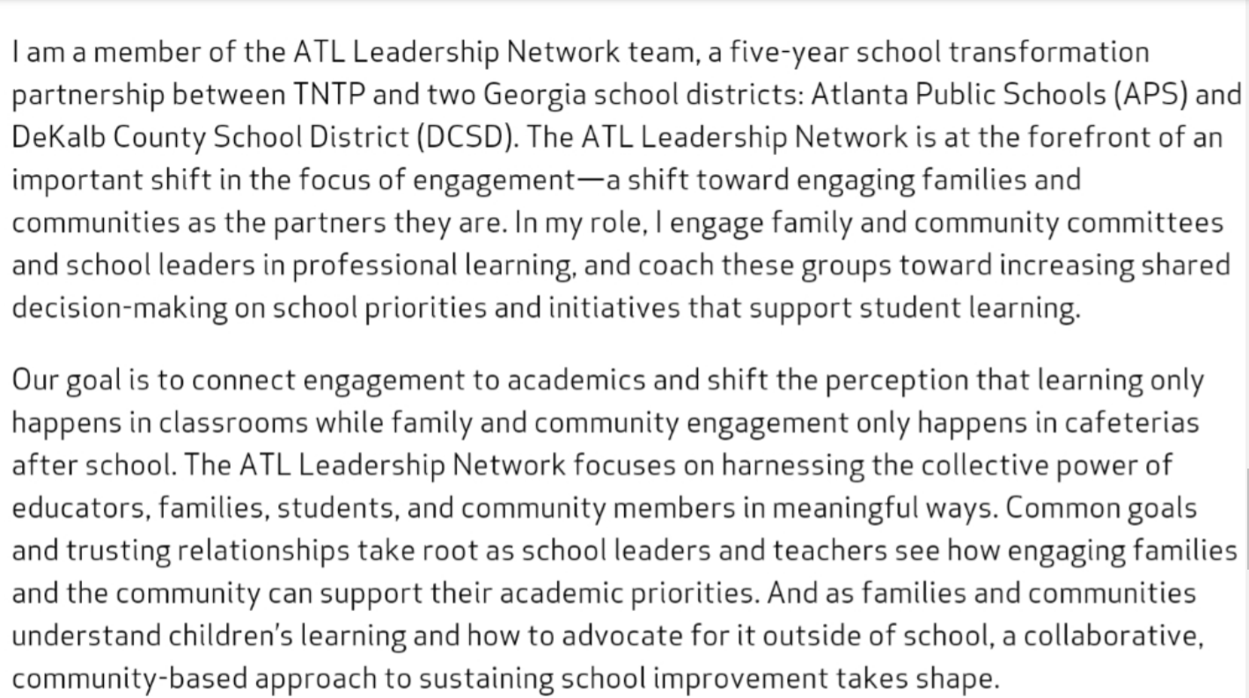
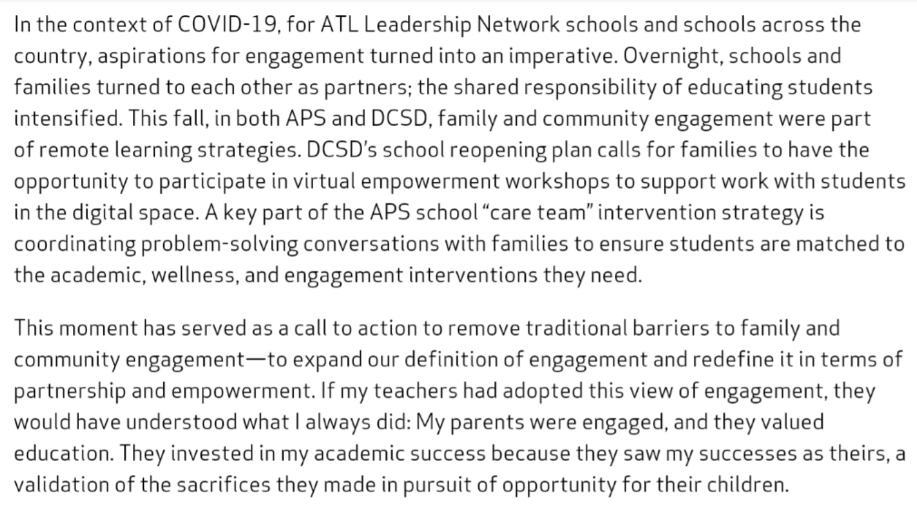
Download source: https://prichardcommittee.org/wp-content/uploads/2021/06/its-time-to-redefine-family-and-community-engagement.pdf
Can you relate to Dahab’s story from your own childhood?

Why does this story matter in an introductory to family engagement training??

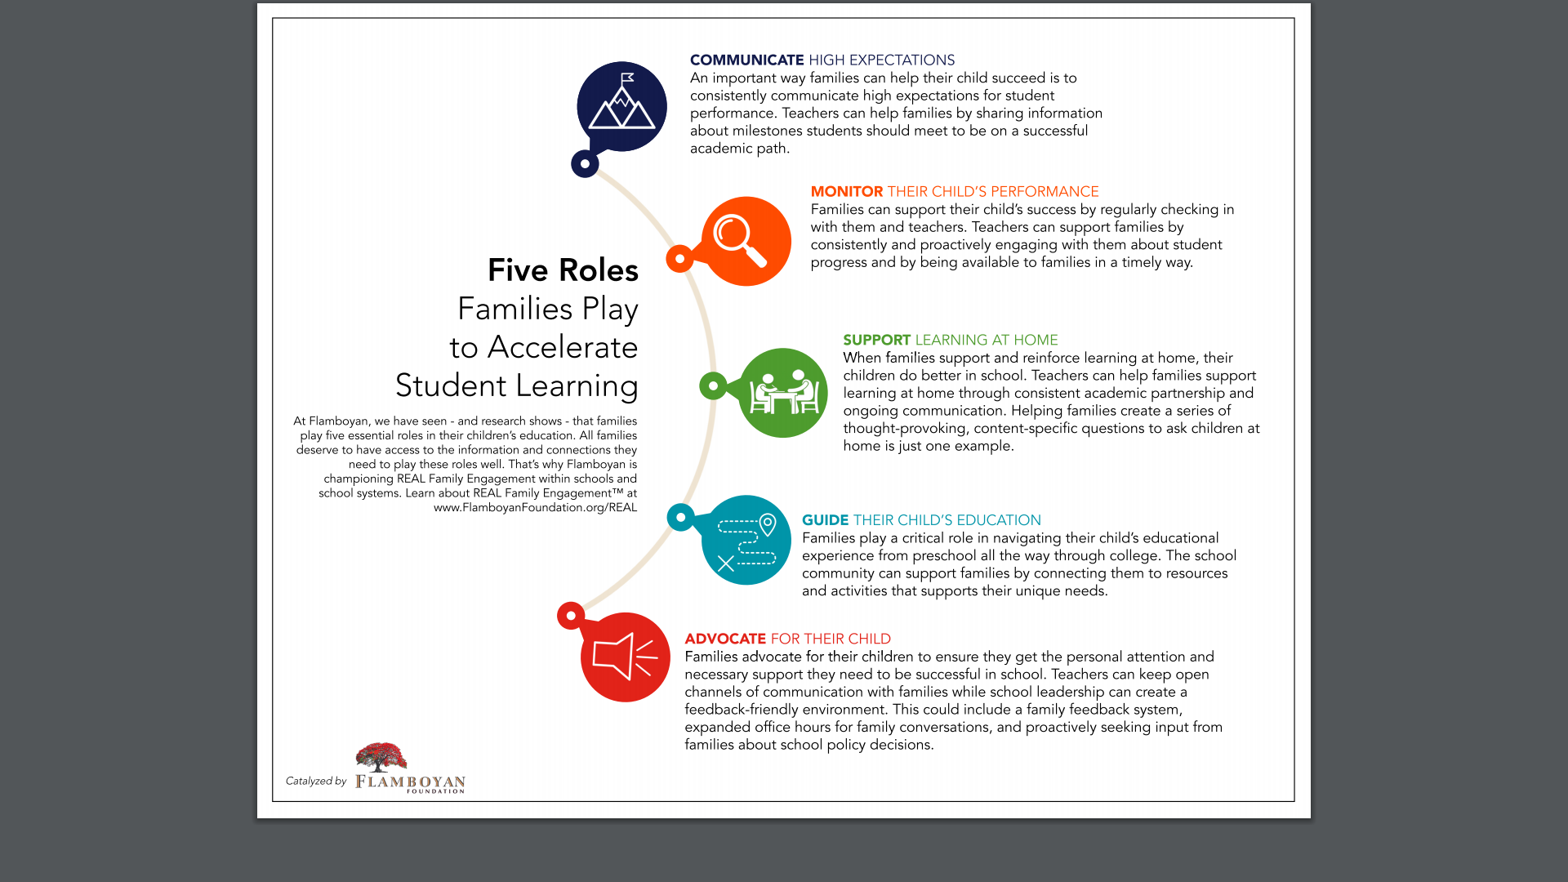
Image retrieved from: https://s28742.pcdn.co/wp-content/uploads/2020/01/Five-Roles-Families-Play_Flamboyan-Foundation.pdf

Choose one of the 5 roles families can play: Communicator, Monitor, Supporter, Guide, or Advocate. As a parent, record how you could be stronger in this role. If you are an educator, record how you could better support families in this role.

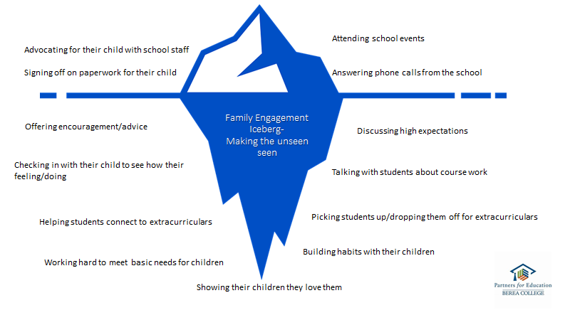

SECTION 4:
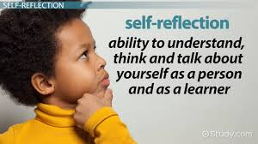
So, what does this mean?
When we think about improving family engagement, we have to move beyond how we improve our family events and newsletters, instead we need to put our time and energy into strategies that help staff get to know families so we can build trusting relationships between families and teachers. ~KY Collaborative for Families and Schools, 2021

“We actually sit down and talk to families”- Carnegie and Harvard Presentation, June 2021

Consider to what extent you agree with this generalization. Consider how your personal experiences as a child and in your current role as either an educator or caregiver shape your beliefs about family engagement.


A Few Great Places to Start

- Figure out how school staff can be paired with students so that EVERY student is covered
- Student/Family Anonymous Survey: Can you name a school staff person you can reach out to if you have questions or concerns?
- Index cards with student names on tables and/or homeroom teachers
- Host trainings for all school staff on working with families to expand outside of teaching staff
- Host an honest conversation with a few family focus groups from diverse roles and grade levels. What should we Start, Stop, Continue
- Welcoming phone calls or home/zoom visits with families
- Rethink Back-2-School Nights
- Do WITH families and teachers not TO
Note and other ideas:

See Impact Video- A Parent Reflects on Building Relationships with Teachers:https://youtu.be/vbyhao0FtaQ
4 Core Beliefs:
- All families have dreams for their children and want the best for them
- All families have the capacity to support their children’s learning
- Families and school staff are equal partners
- The responsibility for cultivating and sustaining partnerships among school, home, and community rests primarily with school staff, especially school leaders.
Circle the belief that resonates with you most and star the belief you are challenged by most.

Consider the impact differences in race, class and culture among families and teachers has on these beliefs.

Check out a Dr. Mapp Explaining these 4 beliefs here: https://www.youtube.com/watch?v=jCKc9AxjDBE

SECTION 5:
What should a school focus on?
- Staff build productive, meaningful relationships with students and families to build trust, confidence, and authentic partnerships.
- A variety of constructive, two-way communication flows regularly between staff, students, and families about academic achievement and individual needs.
- Staff ensures that families have multiple learning opportunities to understand how to support their student’s learning and to participate in decision-making and school improvement efforts.
- Staff identifies and supports at least one family member or another adult in the school for each student who can take personal responsibility for understanding and speaking for that student’s learning needs.
- Staff engages and partners with community members and families to plan and implement substantive work to improve student achievement and school improvement

5 Objectives From: Ky Family and School Partnership School Self-Assessment

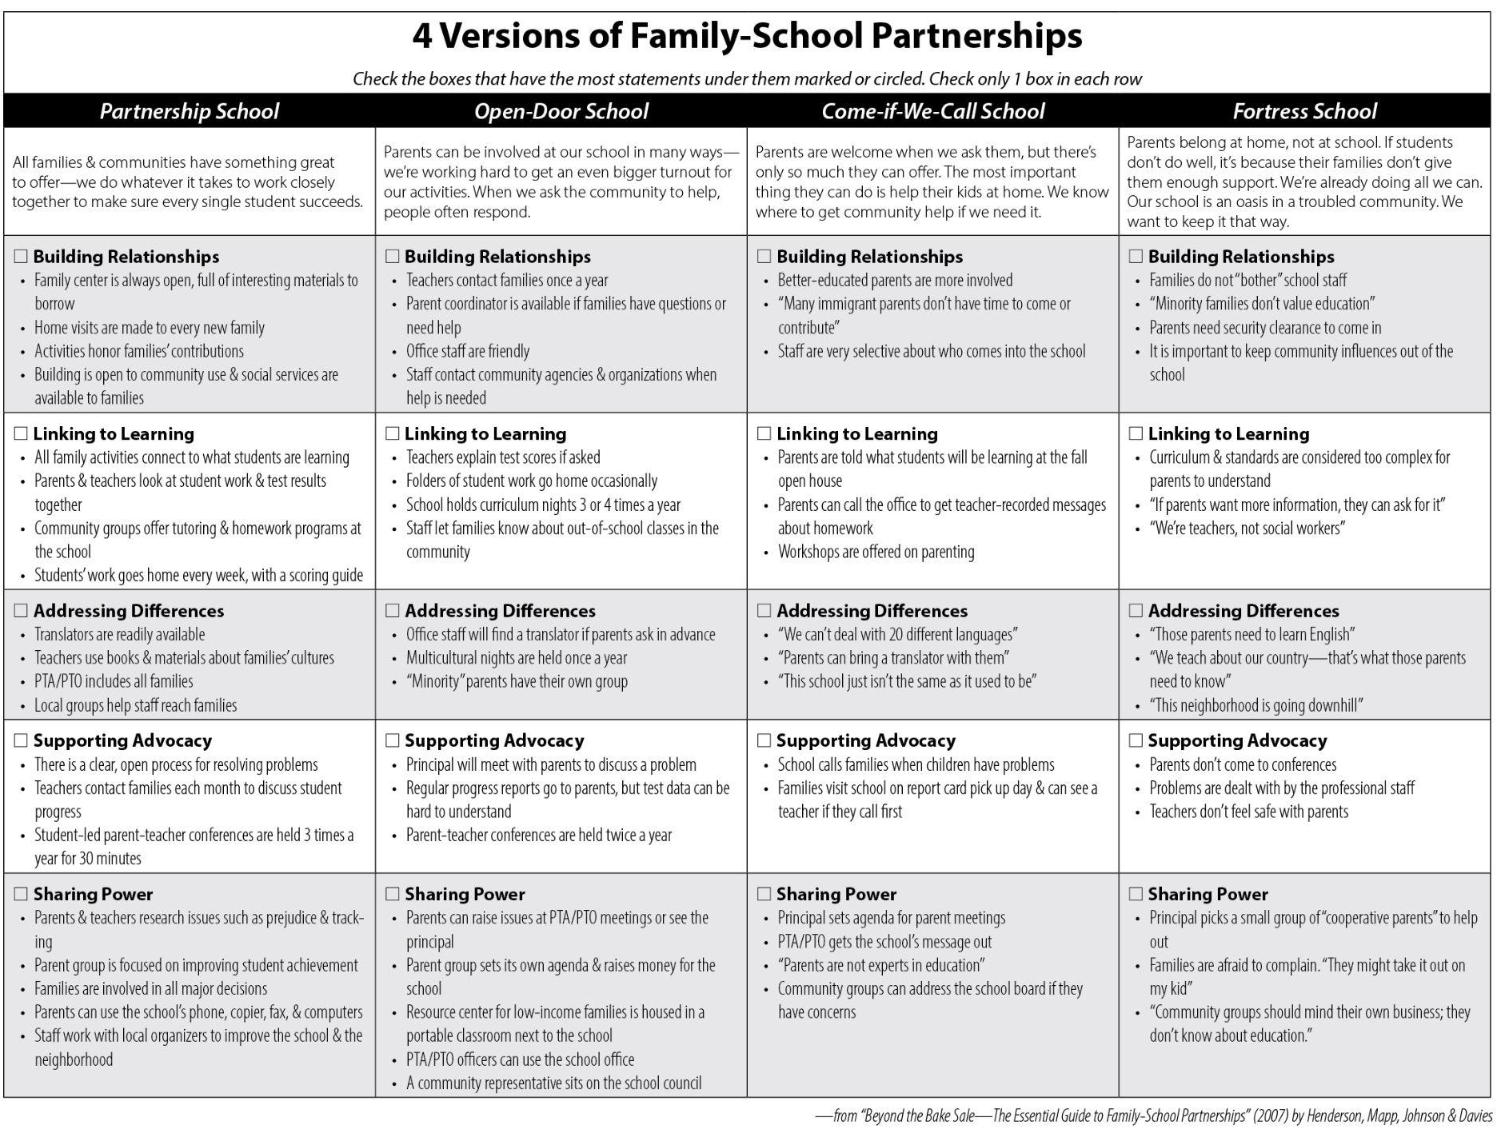
From: https://dpi.wi.gov/sites/default/files/imce/sspw/TSSFamily_FourVersionsofFamilyPartnerships.pdf
11 Goal Post Family Engagement Strategies- A School Year Breakdown
August and September | 1. Teacher wellness and support check-in  2. Welcoming phone calls or home visits  3. Family Friendly Back to School Night  4. Family, administrator and teacher trainings: “KY Family and School Partnership 101 Module”
October | - Focus on School goal setting and action planning.  - Align planning with existing school initiatives, requirements and improvement efforts
November | 5. Effective Family Conferences/ Conversations and IEP Meetings  **Kentucky Family Engagement in Education Week is the 3rd week of November
December | 6. Social and emotional wellbeing: whole child, whole Family  7. Community partnerships and mental health services
January | 8. Improve parent leadership and decision-making roles in the school and district; Student voice in middle and high schools
February | 9. Revisit and improve family-school compacts and family engagement policies  10. Mid-year family and staff check-ins via home visits, virtual visits or phone calls
March | 11. Evaluate family engagement efforts for continuous improvement and ensure equitable practices
April and May | Extras  - Offer summer learning and grade transition supports for families and students  - Collect input and set goals and dates for next year’s engagement programs  - May Teacher Appreciation Week

TIP SHEET #2:


Family Engagement Strategy 2: Welcoming (wellness) Phone Calls to Families Beginning of the school year and mid-year if feasible
Goal: Set a welcoming tone with a strong first impression that shows families the school is an inviting and friendly space. The purpose of the call should also be to allow families to share information about their child and family and begin building an authentic relationship with school staff.
Top Tips:
- Host a 30 minute staff training via Zoom to explain the purpose of these calls and role play an example call for all staff making the calls. Discuss possible scenarios and questions that may arise. Include paraprofessionals, cafeteria staff and other school staff when possible to expand the team.
- Conduct calls before school starts or within the first month. By making these connections before the school year begins and establishing a base level of trust and positive communication early on, families may be more open to communication throughout the year.
- Ask questions such as: “What do you want to share with me about your child? What are your goals for her this year? What are your dreams for your child?” Allow the parent a chance to say everything he or she wants to say.
- Have information about upcoming parent meetings (SBDM, PTA) or other opportunities for parent involvement ready to share if time allows in a way that is very inviting.
- Sample Script for Call
- Questions for Trust Building
For Big Schools, Middle and High Schools:
- Ask for additional school staff, SBDM, PTA and other parent leaders to support making the welcoming phone calls. Be sure to host a training session for anyone making these calls.
- Consider text messages, online videos, handwritten cards or personal emails if phone calls are not practical.
Doing WITH families, not TO families:
- Tell families when you call WHY you are calling. Explain the goal is to ensure families feel welcome and know the school is a friendly place.
- Create questions that allow families to lead the discussion of what they want to share with you about their hopes and dreams for their child. Families should be doing most of the talking.
Equity and Inclusion:
- Families who aren’t reached by phone can’t be disregarded. The goal should be 100% school-family connection. Must consider and try other options when needed.
- Closed captioning, sign language or translation services may need to be provided. Connect with the district office on how to provide these services. - Consider options for families who cannot be reached by phone such as home visits and handwritten cards.
Measuring Success:
- Track number of phone call attempts to reach a family and % of families reached. Increase the goal each year
- Have each teacher self-score from 1-5 on how well they felt the call went and make notes about what they are learning works between calls.
- During orientation night, by survey or social media create a simple diagram where families can checkmark if they received a welcoming phone call and on a scale of 1-5 how much they enjoyed the conversation.
- Have teachers keep notes and consider correlations between families who answered the call, attendance for family conferences, and overall ease of relationship throughout the year. Use these reflections as a peer learning activity during a staff meeting.
“By requesting teachers/staff to make phone calls and asking directly and personally- what do they want from their district to make their student successful? The parent is the voice of the student and personal advocate. Reaching out to the family gives the teacher/district personal knowledge of not only the family but the community and actual needs of their student in real-time. Emails for quick phone meetings are a quick easy way to connect to the parents.” ~ KY Parent
This strategy sheet is part of a series called “KY’s 11 Goal Post Strategies for Family Engagement” these resources and more will be available online after Sept. 1st 2021. Questions or comments contact: Brooke Gill, Director of Family Engagement brooke.gill@prichardcommittee.org
  Tools I am leaving with today:  - Video examples of effective FE  - FE definition and research highlights  - “Dahab’s Story” on Redefining FE  - 5 Roles Families can play  - Where to start ideas  - KY’s 11 Goal Post Strategies  - 5 Objectives for effective family engagement  - 1 new peer support connection  - 1 action item  - KY Family and School Partnership Self-Assessment |   What I can do with these tools:  - Select 1 or 2 tools to share at needs all staff or grade level meeting  - Family focus group material options  - Partner with someone in your school or another school on one idea you liked  - Ask to meet with a school building leader and share key insights and ideas from this training  - Take certain materials to a school council, PTA, etc. to consider as a sub-committee  - Help create a school team to take this training and then work together on next steps
Use it or lose it:
- My first action item:

- Who can support me?
- Who can I support?
- First follow-up meeting date:
- Second follow-up meeting date:

HOMEWORK before moving on to Part 2::
- You + 2 others at a minimum compete the: Ky Family and School Partnership Self- Assessment
- Try to recruit diverse voices- 1 parent, 1 educator and 1 school leader. Multiple from these audiences would be ideal so you can average their scores before Part 2 Module

Beginning of Part 2 of 2
Section 6:
KY Family and School Partnership Self-Assessment:
*REMINDER: Your Homework from Part 1 was for You + 2 others (at a minimum) complete the: Ky Family and School Partnership Self- Assessment Try to recruit diverse voices- 1 parent, 1 educator and 1 school leader. Multiple from these audiences would be ideal so you can average their scores before Part 2 Module.
How did you score?
 | Participant 1 (or family average) | Participant 2 (or educator average) | Participant 3 (or school administrator average)
Overall score | /60 | /60 | /60
Objective 1:  Relationship Building | /15 | /15 | /15
Objective 2:  Communications | /12 | /12 | /12
Objective 3:  Shared Responsibility | /12 | /12 | /12
Objective 4:  Advocacy | /9 | /9 | /9
Objective 5:  Community Partnerships | /12 | /12 | /12

Self-Assessment Results are NOT a finish line or a grade.
It’s a baseline reading to inform your school of where you are strong and where there is the most potential for growth. It also gives a diverse group of families, educators, and building leaders a concrete place to start so there is common language and a way to measure improvement as you go.
First, dig into the findings a bit…
- What strengths can I identify?
- What are areas for development?
- Where was there the most agreement?
- Where was there the most disagreement?
- How do these findings compare to our other school data such as annual parent surveys, event attendance, etc? Or as a parent or educator how do these scores compare to your personal experiences?
Next, record a few reflections below each objective. Consider the Critical Attributes list for each.
- Staff build productive, meaningful relationships with students and families to build trust, confidence, and authentic partnerships.

- A variety of constructive, two-way communication flows regularly between staff, students, and families about academic achievement and individual needs.

- Staff ensures that families have multiple learning opportunities to understand how to support their student’s learning and to participate in decision-making and school improvement efforts.

- Staff identifies and supports at least one family member or another adult in the school for each student who can take personal responsibility for understanding and speaking for that student’s learning needs.

- Staff engages and partners with community members and families to plan and implement substantive work to improve student achievement and school improvement

Take an inventory of current family engagement practices and/or touchpoints: A touchpoint is a regular time when you interact with families, if only briefly or one-way communications such as orientation, pick-up/drop-off, report cards sent home, newsletters, etc.

SECTION 7:
Current Programming and the Dual-Capacity Building Framework
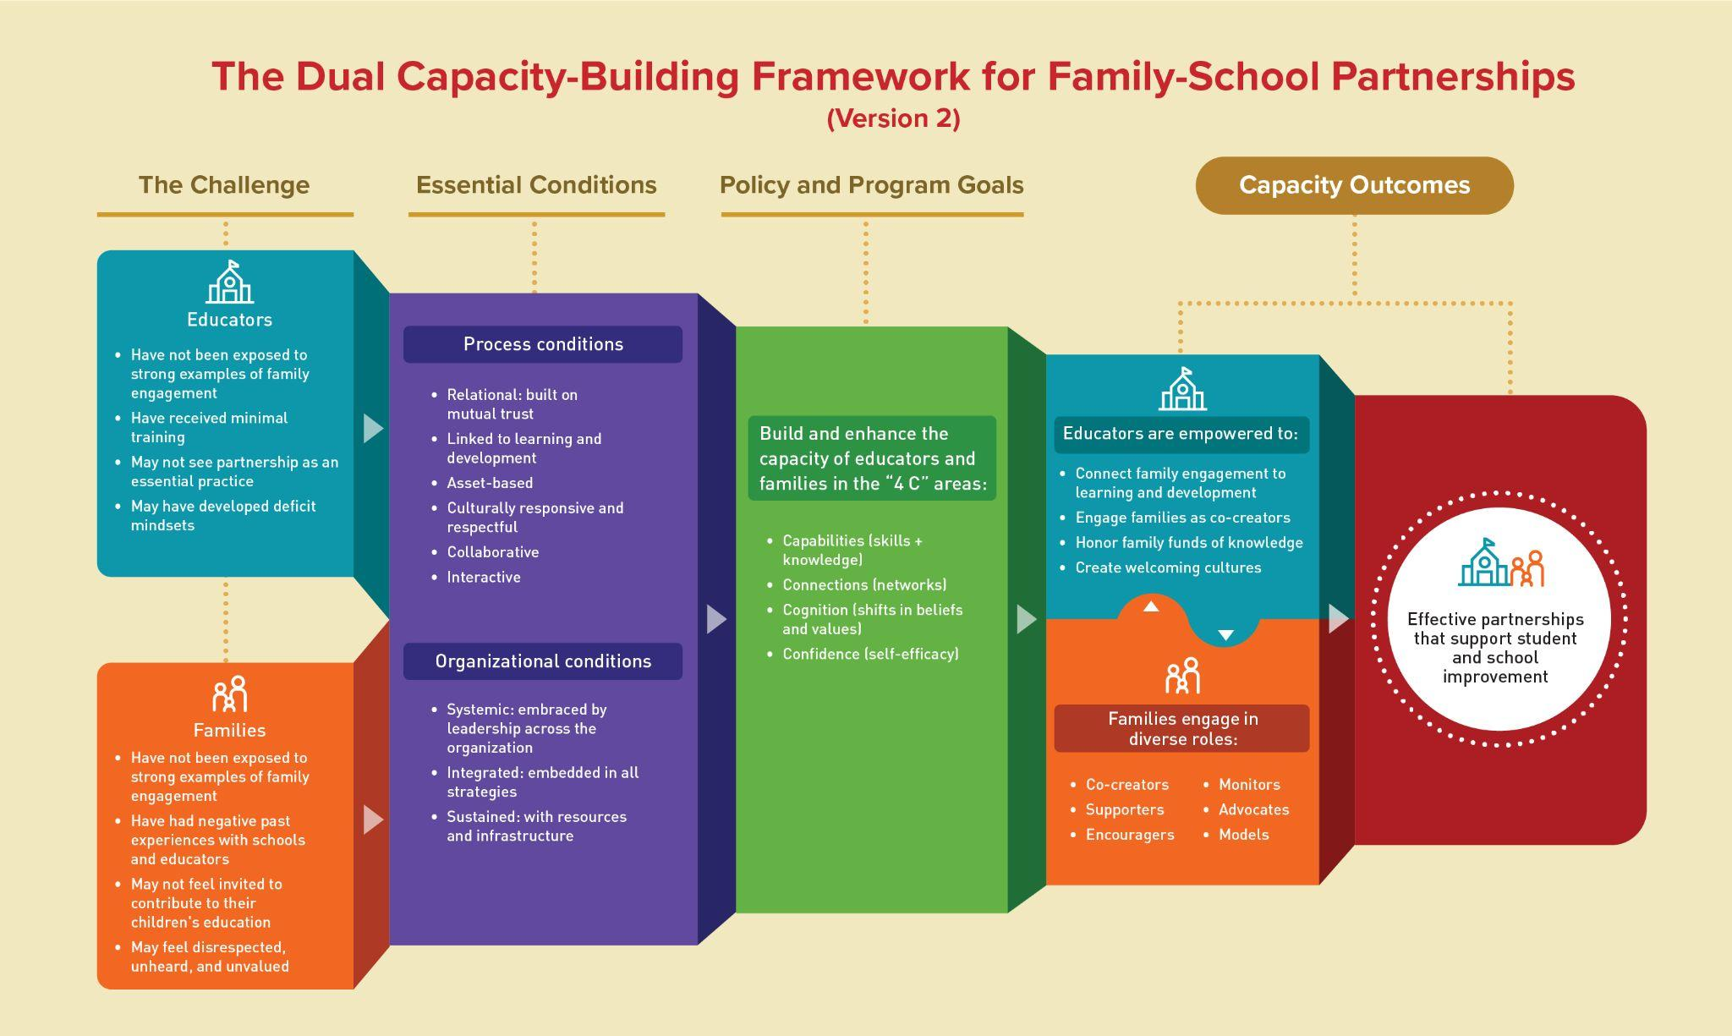
dualcapacity.org
SECTION 8:
Dual Capacity 6 Essential Process Conditions:
- Relational: Built on trust
- Linked to Learning
- Asset-based
- Culturally responsive and respectful
- Collaborative
- Interactive
Essential Process Conditions in Action:
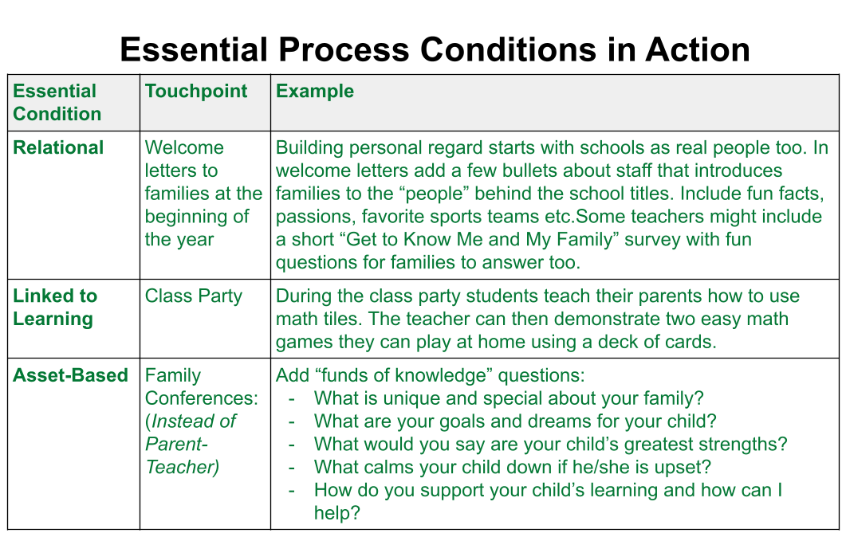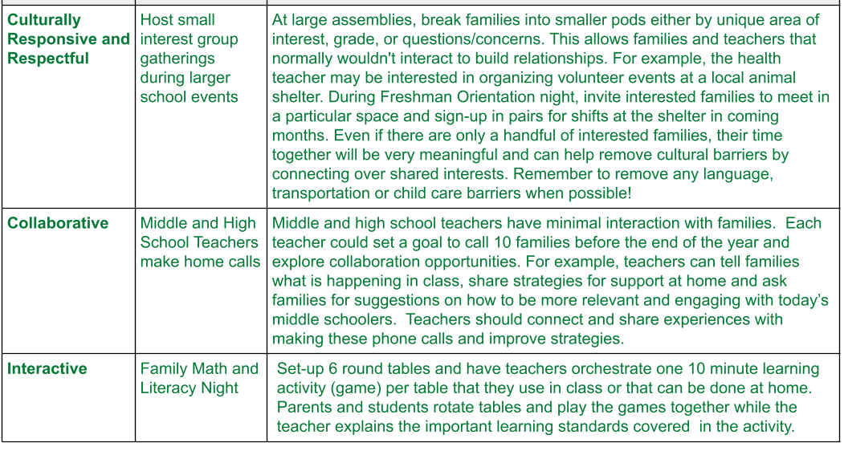

When planning a Family Engagement event, program or initiative consider these conditions:
1. Relational
• Are we helping to build authentic trusting relationships between families and the school? • How is the school/school-staff seeking input from all families? (Respect)
• Do school/school-staff honor the expertise of families in their role as caretaker? (Competence)
• How can school/school-staff consistently show families that they are interested and invested in the core roles that families hold at their school? How do schools ensure that they clearly communicate and then follow through on what they say they will do? (Integrity)
• Does the school seek out ways to show families that they value and care about them as people and stakeholders? (Personal Regard)

2. Linked to Learning
• Are families taking home new ideas that they can use to support their child’s academic and development needs in the classroom and at home?
• Does the experience provide a concrete way for a family to support their child’s learning at home either through conversation starters or activity materials?
• Does the experience provide a way for families to share their understanding of their child’s learning with educators?
• Is school staff acknowledging families as capable of learning and as part of the teaching team for their child?

3. Asset-Based (Strengths-Based)
• How are we drawing on each families’ funds of-knowledge about their child? Funds of knowledge: The idea that families have explicit and important knowledge about their child and their community that is extremely valuable for a teacher (Moll, Amanti, Neff and Gonzalez, 2005).
• How are we providing opportunities for families to shine and tell us what they are good at and what they can offer as part of the school family?
• Is the school staff open to the variety of roles families can play based on their strengths, unique interests and personality type?

4. Culturally responsive and respectful (Equitable Practices)
• How do we celebrate differences among our students and families?
• Are we providing opportunities for Families to Engage in Diverse Roles? Families can be Co creators, Supporters, Encouragers, Monitors, Advocates, and/or Models
• Do we make it a priority to address language barriers in all school communications? Do staff know family members’ level of literacy?
• How do we connect family cultures to what students are learning? Personally invite families to come to class and teach about their different cultures and traditions
• Do we know what cultures and countries our students come from? Do we know why this is important?
• Do we know why we make it a point to consult various representative groups of parents, not only those who attend PTA/PTO, etc.?
• How do we highlight the various ways parents are supporting their kids in atypical ways such as clever homework strategies, extracurricular experiences and talking to their child about college and career goals?

5. Collaborative
• Are we intentional in helping families be friends with other families? Are we creating activities and experiences that help these real connections happen?
• How do we work with families to identify their role and build a “job description” as a parent in the school?
• Do we survey families about how they want to connect with other families, teachers and school staff?
• Do we have a school policy that ensures each family can name at least one person in the school they can call if they need something?
• How could we utilize all staff in the building to make personal contact with every family at least twice a year?
• Do we ensure students have a voice in their education plan as part of the parent and teacher collaborative team?

6. Interactive
• How can we enhance our usual events so families and students can interact with the information being shared?
• When planning events for families do we consider the Principles of Adult Learning?
1. Adults must want to learn
2. Adults will learn only when they feel they need to learn
3. Adults learn by doing.
4. Adults learning focuses on problems, and the problems must be realistic
5. Experience affects adult learning
6. Adults learn best in an informal situation
7. Adults want guidance
Click here to view the Essential Conditions in Action Examples shown in PPT
EXAMPLE: Essential Process Conditions in Action
Touchpoint/Event/Activity Name:Back to School Night

- Relational: Built on trust
- Host different grade levels on different nights to make the event more personal
- Add icebreakers, people scavenger hunt, etc. so families can meet one another
- Linked to Learning
- Each teacher needs to share one-way families can support their child’s learning at home within the first month of school (a list of questions to ask, a learning material or activity for home, etc.)
- Asset-based
- Consider multiple sign-ups with a variety of ways families can offer their time and talents. Think outside the box! Ex. Volunteers write new families welcome cards with contact information, help with school mailings, post something positive to the school social media page, take a school survey about improving family conferences, help find community service options for students, ELL ambassadors, etc.
- Culturally responsive and respectful
- Translate all materials, signs and have interpretation available. Advertise events in different languages too.
- Consider hosting back-to-school events at community centers.
- Collaborative
- Do WITH families and not TO families. ASK families what they would like to see at the event and ASK educators what they have heard of or seen at other schools that they would like to replicate.
- Ask if ELL families mind to mentor and guide new ELL families
- Interactive
- Move information to materials only with YouTube videos as needed so most of the time can be spent in conversation between families and educators and among families. Ensure scavenger hunts and interactive games don’t isolate parent and student rather opens up to all families and educators available.


Your turn!

Consider one Family Engagement Activity or Touch Point from your list above. Try to embed the 6 Essential Conditions into this touchpoint (you may want to use one that already has a star- start where you are strong!):

Touchpoint/Event/Activity Name: ___________________________

- Relational: Built on trust

- Linked to Learning

- Asset-based

- Culturally responsive and respectful

- Collaborative

- Interactive

Use the Dual-Capacity “4Cs” to measure if activities are working...
1. Building Capabilities?
• Do participants have an opportunity to put new knowledge into practice?
• Did participants gain a new skill they now use to support student achievement or family school partnership?

2. Making new Connections?
• Did participants make new connections and expand their network?
• Were lasting relationships formed as a result of their involvement?

3. Changing Cognition?
• Did participants have a positive shift in beliefs and values related to equity and excellence in education?
• Were participants encouraged to take on a more active role in the family-school partnership team?

4. Building Confidence?
• Do families have more confidence about supporting their child’s academic and developmental needs because of this activity?
• Do teachers feel more equipped to engage and welcome families as partners?

Write 2 survey questions you could use to measure the impact of your touch point example based on these 4C’s

1.)

2.)


SECTION 9:
Videos from district, classroom and parent perspectives (video link here)
- Jay Brewer, Dayton Independent KY Superintendent, “To GROW students, we have to KNOW students”
- Ashton Bolanos, Leestown Middle School, Family Resource Center Coordinator- Homeroom Teacher Strategy
- Ruth Willoughby, Parent Leader, Fayette County- Power of Parent Leadership
SECTION 10:
Next Steps: Digital Playbook and Family Engagement Action Teams
Examples of who to recruit for your Family Engagement Action Team:
• 3-4 diverse family members: These members should represent the diversity of the student population. Stipend for time, childcare and travel is recommended. Example members:
• A parent who is historically not engaged in school activities
• A parent in an elected position or very involved
• A grandparent or relative caregiver
• Family members from different grade levels
• 2-3 classroom teachers
• Educator preparation program representative (where appropriate)
• Family resource coordinator or family engagement staff when available
• 1 member from a community organization
• 1 school administrator (Principal or Assistant Principal)
WAIT! Let’s Work Smarter, not Harder...
A Family Engagement Action Team might be developed and implemented through an existing school council such as the School-Based Decision Making Council, MTSS Leadership Team, Equity Team, Trauma-Informed Action Team, Family Resource and Youth Service Center Advisory Council, etc. This addition to their work scope could increase meaningfulness and engagement or as a sub-committee within these existing councils. Recognize that you may need to recruit new members and voices to get diverse input. You want to be sure the action team adequately represents the student and teacher population. Start with current parent teacher teams and get their feedback on how to grow a diverse team to oversee family engagement efforts.
Examples of what Family Engagement Action Teams can do:
1. Develop a 1-year action plan that covers each area you will work on, create a budget and identify sources of funding.
2. Meet regularly (at least monthly) as a whole team and establish goals and guidelines for teamwork. How will you communicate? What decision-making process will you use? When will you allow time to discuss issues and solve problems?
3. Gather ideas and plan programs and activities. See Digital Playbook for Family Engagement Ideas.
4. Publicize activities and team meetings. Include all families and the school community. Make a concerted effort to reach out to families that are normally not engaged.
5. Evaluate your work and report regularly on progress in meeting the plan
Who might be on your family engagement action team? (Remember to consider existing groups wanting deeper work and HOW they might gather the voices of families not represented on the team)

Where to start?
- Set intention- draft a sample goal statement for the team
- Identify the team
- Complete and Compare Self-Assessment Results or the Part 1 “What Type of School Are You?” shorter assessment
- Prioritize and action steps. Start small but intentional.
- Decide how the team will stay connected and keep documents organized
- Decide how the team will be transparent, inclusive, diverse and welcoming of new members
How can you start setting the intention and building the team?


Many ways to go from here..

- Family Engagement Action Team
- Pick a strategy from the Digital Playbook
- SMART Goal
- Action Plan Template

Re-record “Your Use it or lose it” from Part 1

- My first action item:
- Who can support me?
- Who can I support?
- First follow-up meeting date:
- Second follow-up meeting date:
OR Start New:
Write a SMART Goal- Make it Specific, Measurable, Action Oriented, Realistic, and Timely
Ex. “I will recruit 2 teachers and 2 parents from the 6th grade team to take this training by October 31. We will meet before November 15th for 45 minutes to discuss results from our Self-Assessments and decide where we want to start and who at the leadership level could support our efforts. We will also pick a second meeting date and 2 additional people to include to improve the diversity of the team.”
YOUR SMART GOAL:

 | Family Engagement Action Team | New FE Strategies in the school
30 day goal
60 day goal
90 day goal

FAMILY ENGAGEMENT ACTION PLAN TEMPLATE

Family  Touchpoints | Partnership Strategy/Activity | Beginning  steps | How will we engage families including those who are more difficult to reach?
What can we do before school begins?

Consider: Welcome phone calls, home visits, and welcome letters

What can we do at the beginning of the school year?
Consider: Back-to-school night, opportunities for parent connection

Family Conferences
Consider: Linked to Learning and Relationship Building

Current School Compliance, Improvement and Survey Efforts

Consider: Quality rating and improvement efforts

Existing Parent Leadership Opportunities
Consider: More Interactive and owning on-going Family Engagement efforts

What can we do at the end of the school year?
Consider: End of Year celebrations, transition supports, community partnerships for summer learning opportunities

Other:
District and school leadership Consider:
Educator wellness and support before school starts

Other:
Consider: Mid-Year Family Check-Ins, home visits, annual celebration events, drop-off and pick-up, and other routine family touch-points
Other: Start with the Student Academic Outcome
Consider: Starting your Action Plan with the Student Academic Outcome rather than the event. Build the event off the student outcome goal. I.e. increase K-Readiness, or 3rd Grade Reading.

Tools I am leaving with today:  (Full 3 hours):  - Video examples of effective FE  - FE definition and research highlights  - “Dahab’s Story” on Redefining FE  - 5 Roles Families can play  - Where to start ideas  - KY’s 11 Goal Post Strategies  - 5 Objectives for effective family engagement  - Quick School Self Reflection Tool  - 1 action item and 1 new connection (in person/live)  - KY Family and School Partnership Self-Assessment  - Reflections and analysis of Self-Assessment results  - Dual Capacity Image  - One concrete Action  - Ky Family and School Partnership Guide | What I can do with these tools:  - Select 1 or 2 tools to share at all staff or grade level meeting  - Family focus group material options  - Partner with someone in your school or another school on one idea you liked  - Ask to meet with a school building leader and share key insights and ideas from this training  - Take certain materials to a school council, or another parent organization to consider as a sub-committee  - Help create a school team to take this training and then work together on next steps

Get more information and tools by visiting: https://prichardcommittee.org/familyengagement/ .
Please share your feedback on this module so we can continue to improve our resources:
Feedback Survey
Proof of Completion Survey- for entire training (3 hours) Click Here
Ky Family and School Partnership Guide
Ky Family and School Assessment
Questions or comments: brooke.gill@prichardcommittee.org


