Online Training Module- Learning Journal

for

**“Shared Responsibility & Advocacy”**

Dear Early Education Educators,

Use this reflection journal to follow along with the 1-hour online training video. There are questions at the end of each of the 2 sections of the video. To receive ECE-TRIS credit and a certificate for the course: At the end of the 2 video sections, you will be prompted to type these answers into an online form. Once submitted, you will receive a certificate you can print and submit along with other needed 

documentation for ECE-TRIS credit.

Thank you and we hope you enjoy this module.

**Learning Objectives (1 hour):**

* Identify ways to engage families in shared responsibility in their child’s learning
* Identify ways to support family participation in program decision-making
* Describe ways that centers can support collaborative learning for families
* Describe how centers can support and encourage families to participate in leadership and decision-making roles
* Identify the ways in which centers can honor each families’ knowledge of their child

**Recommended reading and references:**

* KY Family and Early Education Partnership Self-Assessment (2022)
* KY Family and Early Education Program Partnership Guide (2022)
* Family Feedback Survey can be found in the KY Family and Early Education Partnership Playbook

**Section 1 Notes: Shared Responsibility**

*Add notes in this section in response to prompts in the video. Consider how your center*

*addresses each of the critical attributes. These notes will help you complete the*

*self-assessment later.*

1. Does your center offer an annual open house for families at which information on

Early childhood standards, curriculum, child development and community resources

are shared?

___________________________________________________________________

___________________________________________________________________

___________________________________________________________________

___________________________________________________________________

1. Does your center offer at least two family engagement events per year? What can

your center add to your events to better link families to learning?

___________________________________________________________________

___________________________________________________________________

___________________________________________________________________

___________________________________________________________________

1. Does your center inform families of their child’s goals and ask for input at family

events?

___________________________________________________________________

___________________________________________________________________

___________________________________________________________________

___________________________________________________________________

1. Does your center staff provide at least two at-home learning activities per year that

are based on children’s learning and development ?

___________________________________________________________________

___________________________________________________________________

___________________________________________________________________

___________________________________________________________________

1. Does your center invite families to share family-to-family activities and strategies at

least three times per year?

___________________________________________________________________

___________________________________________________________________

___________________________________________________________________

___________________________________________________________________

1. Does your center honor family contributions as partners in their child’s learning?

___________________________________________________________________

___________________________________________________________________

___________________________________________________________________

___________________________________________________________________

1. Does your center have opportunities for family leadership and encourage families

to participate?

___________________________________________________________________

___________________________________________________________________

___________________________________________________________________

___________________________________________________________________

1. Does your center have a family-staff committee that collects and reviews input from

enrolled families? Does your center actively recruit families for involvement?

___________________________________________________________________

___________________________________________________________________

___________________________________________________________________

___________________________________________________________________

1. Does your center ask families to share and update information on their child’s strengths,

areas of concern, and interests?

___________________________________________________________________

___________________________________________________________________

___________________________________________________________________

___________________________________________________________________

1. Does your center offer developmental screening and ask for family input?

___________________________________________________________________

___________________________________________________________________

___________________________________________________________________

___________________________________________________________________

**Section 1 Reflection Journal: Shared Responsibility**

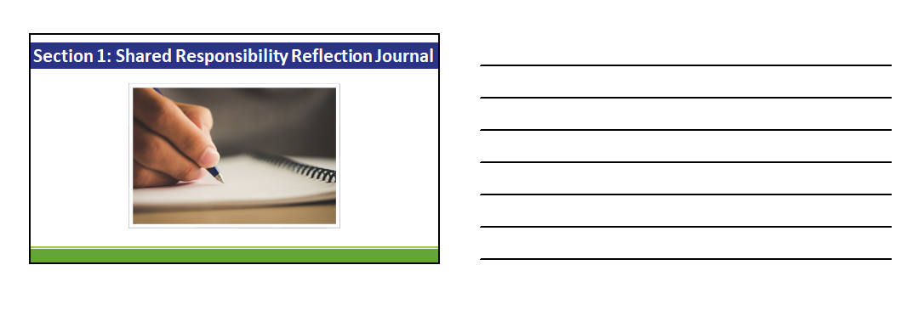

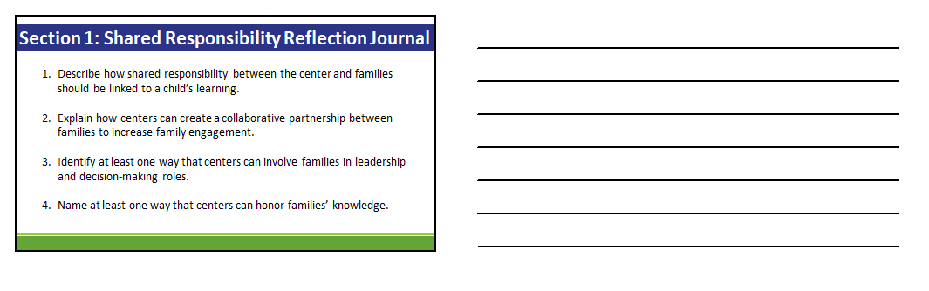

**Section 2 Notes: Advocacy**

*Add notes in this section in response to prompts in the video. Consider how your center*

*addresses each of the critical attributes. These notes will help you complete the*

*self-assessment later.*

1. Does your center intentionally communicate with families on their child’s

development needs throughout the year?

___________________________________________________________________

___________________________________________________________________

___________________________________________________________________

___________________________________________________________________

1. Does your center use evidence-based developmental screening? Does your center

refer families to services based on identified needs from developmental screenings?

___________________________________________________________________

___________________________________________________________________

___________________________________________________________________

___________________________________________________________________

1. Does your center make community service information available at a centralized

location in the center during hours of operation?

___________________________________________________________________

___________________________________________________________________

___________________________________________________________________

___________________________________________________________________

1. Does your center support families and children with written Individualized Education

Plans or Individualized Family Service Plans? Does your center offer space and/or

scheduling flexibility for children to attend outside therapies as needed?

___________________________________________________________________

___________________________________________________________________

___________________________________________________________________

___________________________________________________________________

1. Does your center support families and children as they transition between age

groups and/or facilities and kindergarten? Does your center have a transition plan

in place in which the parent provides input regarding their child’s transition?

___________________________________________________________________

___________________________________________________________________

___________________________________________________________________

___________________________________________________________________

1. Does your center have policies and procedures in place for addressing and resolving

family issues and concerns?

___________________________________________________________________

___________________________________________________________________

___________________________________________________________________

___________________________________________________________________

1. Does your center support families as their child’s best advocate? What supports are

in place?

___________________________________________________________________

___________________________________________________________________

___________________________________________________________________

___________________________________________________________________

1. Does your center support and empower families as change agents for their child?

Does your staff review program data, policies, and procedures with families for

program quality improvement?

___________________________________________________________________

___________________________________________________________________

___________________________________________________________________

___________________________________________________________________

**Section 2 Reflection Journal: Advocacy**

